**C-DAC Mumbai Date 26/09/2024**

**Subject: Algorithm and Data Structure**

**Assignment 1**

**Solve the assignment with following thing to be added in each question.**

-Program

-Flow chart

-Explanation

-Output

-Time and Space complexity

1. Printing Patterns

Problem: Write a Java program to print patterns such as a right triangle of stars.

**package** org.example5;

**import** java.util.Scanner;

**public** **class** Program {

**public** **static** **void** main(String[] args) {

Scanner sc = **new** Scanner(System.***in***);

System.***out***.println("Enter the height of the triangle: ");

**int** h = sc.nextInt();

**for** (**int** i = 1; i <= h; i++) {

**for** (**int** j = 1; j <= i; j++) {

System.***out***.print("* ");

}

System.***out***.println();

}

sc.close();

}

}

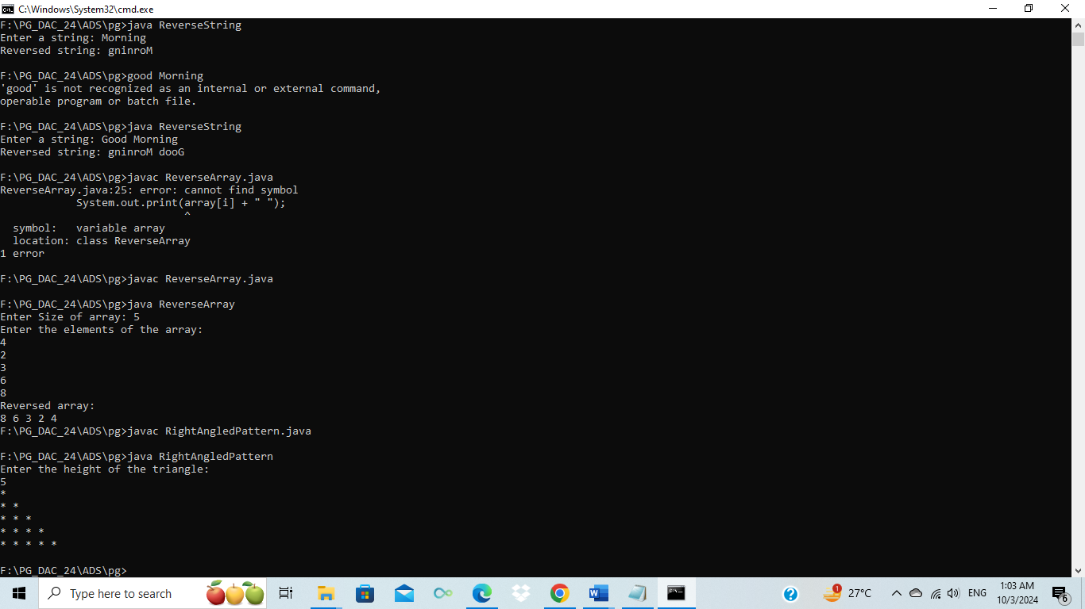

2. Remove Array Duplicates

Problem: Write a Java program to remove duplicates from a sorted array and return the new length of the array.

import java.util.Scanner;

public class RemoveArrayDuplicates {

private static int removeDuplicates(int[] arr) {

if (arr.length == 0) return 0;

int uniqueIndex = 1;

for (int i = 1; i < arr.length; i++) {

if (arr[i] != arr[i - 1]) {

arr[uniqueIndex++] = arr[i];

}

}

return uniqueIndex;

}

public static void main(String[] args) {

Scanner sc = new Scanner(System.in);

System.out.print("Enter the size of array: ");

int n = sc.nextInt();

int[] arr = new int[n];

System.out.println("Enter the sorted array elements:");

for (int i = 0; i < n; i++) {

arr[i] = sc.nextInt();

}

int newLength = removeDuplicates(arr);

System.out.println("New length: " + newLength);

System.out.print("Array after removing duplicates: ");

for (int i = 0; i < newLength; i++) {

System.out.print(arr[i] + " ");

}

sc.close();

}

}

3. Remove White Spaces from String

Problem: Write a Java program to remove all white spaces from a given string.

import java.util.Scanner;

public class RemoveWhiteSpace {

private static String removeSpace(String str) {

return str.replace(" ", "");

}

public static void main(String[] args) {

Scanner sc = new Scanner(System.in);

System.out.print("Enter a string: ");

String input = sc.nextLine();

String result = removeSpace(input);

System.out.println("String without white spaces: " + result);

sc.close();

}

}

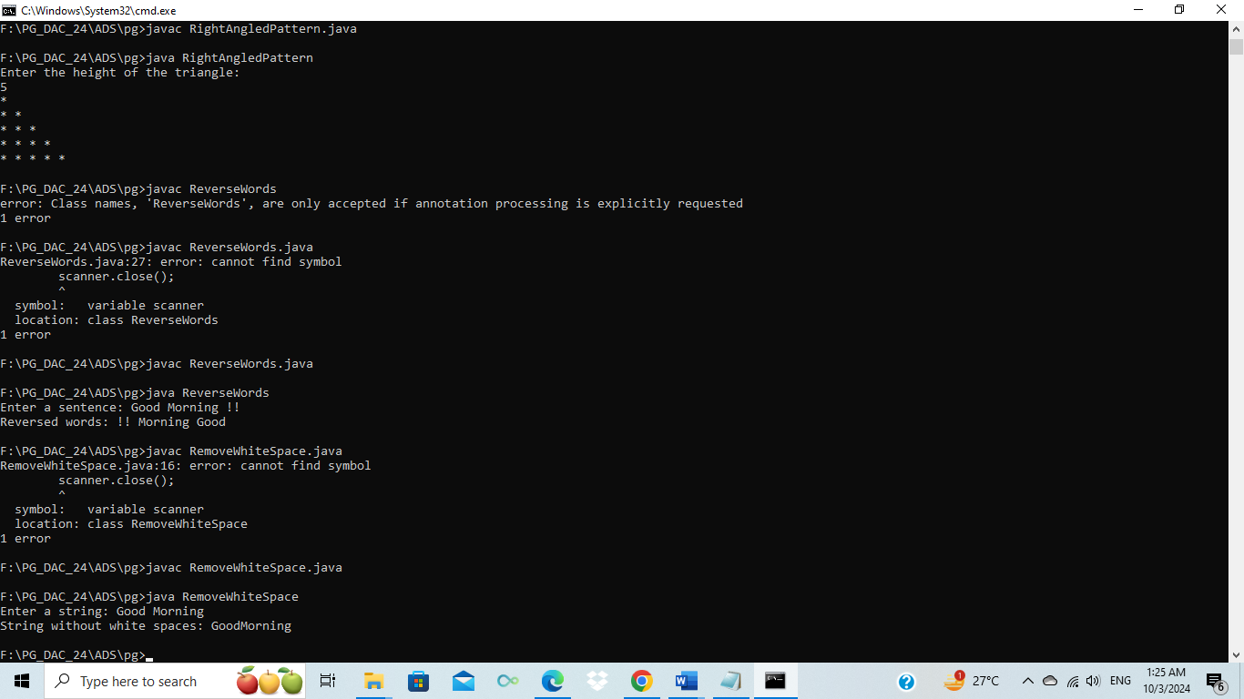

4. Reverse a String

Problem: Write a Java program to reverse a given string.

import java.util.Scanner;

public class ReverseString {

public static void main(String[] args) {

Scanner sc = new Scanner(System.in);

System.out.print("Enter a string: ");

String input = sc.nextLine();

String reverse = "";

for (int i = input.length() - 1; i >= 0; i--) {

reverse += input.charAt(i);

}

System.out.println("Reversed string: " + reverse);

sc.close();

}

}

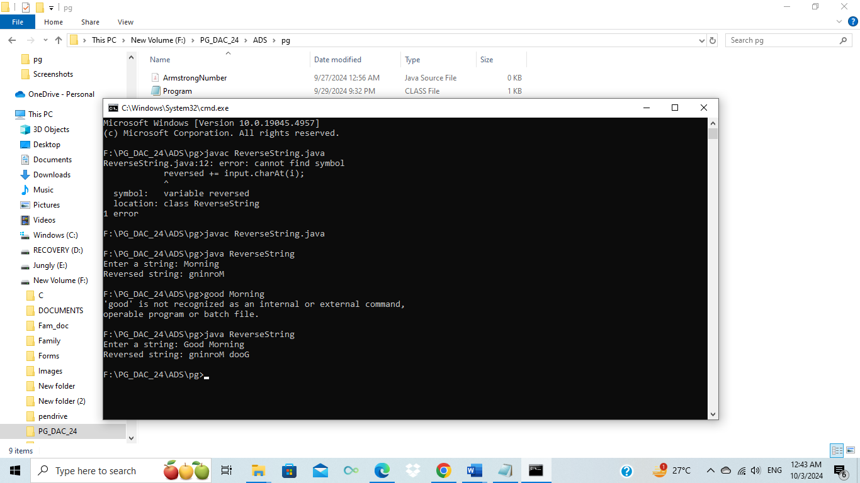

5. Reverse Array in Place

Problem: Write a Java program to reverse an array in place.

import java.util.Scanner;

public class ReverseArray {

public static void main(String[] args) {

Scanner sc = new Scanner(System.in);

System.out.print("Enter Size of array: ");

int n = sc.nextInt();

int [] arr= new int[n];

System.out.println("Enter the elements of the array:");

for (int i = 0; i < n; i++) {

arr[i] = sc.nextInt();

}

for (int i = 0; i < n / 2; i++) {

int temp = arr[i];

arr[i] = arr[n - i - 1];

arr[n - i - 1] = temp;

}

System.out.println("Reversed array:");

for (int i = 0; i < n; i++) {

System.out.print(arr[i] + " ");

}

sc.close();

}

}

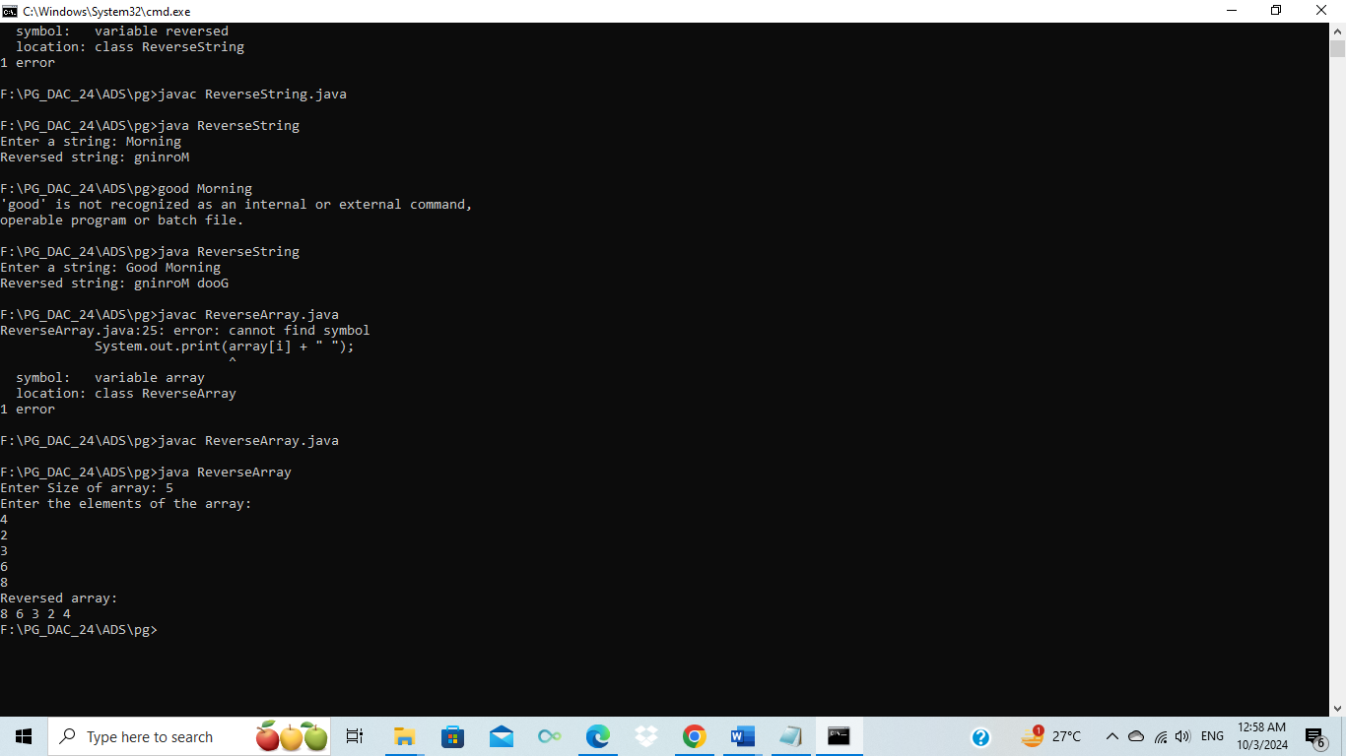

6. Reverse Words in a String

Problem: Write a Java program to reverse the words in a given sentence.

import java.util.Scanner;

public class ReverseWords{

private static String reverseWords(String str) {

String[] words = str.split(" ");

StringBuilder reversed = new StringBuilder();

for (int i = words.length - 1; i >= 0; i--) {

reversed.append(words[i]);

if (i != 0) {

reversed.append(" ");

}

}

return reversed.toString();

}

public static void main(String[] args) {

Scanner sc = new Scanner(System.in);

System.out.print("Enter a sentence: ");

String input = sc.nextLine();

String reversedSentence = reverseWords(input);

System.out.println("Reversed words: " + reversedSentence);

sc.close();

}

}

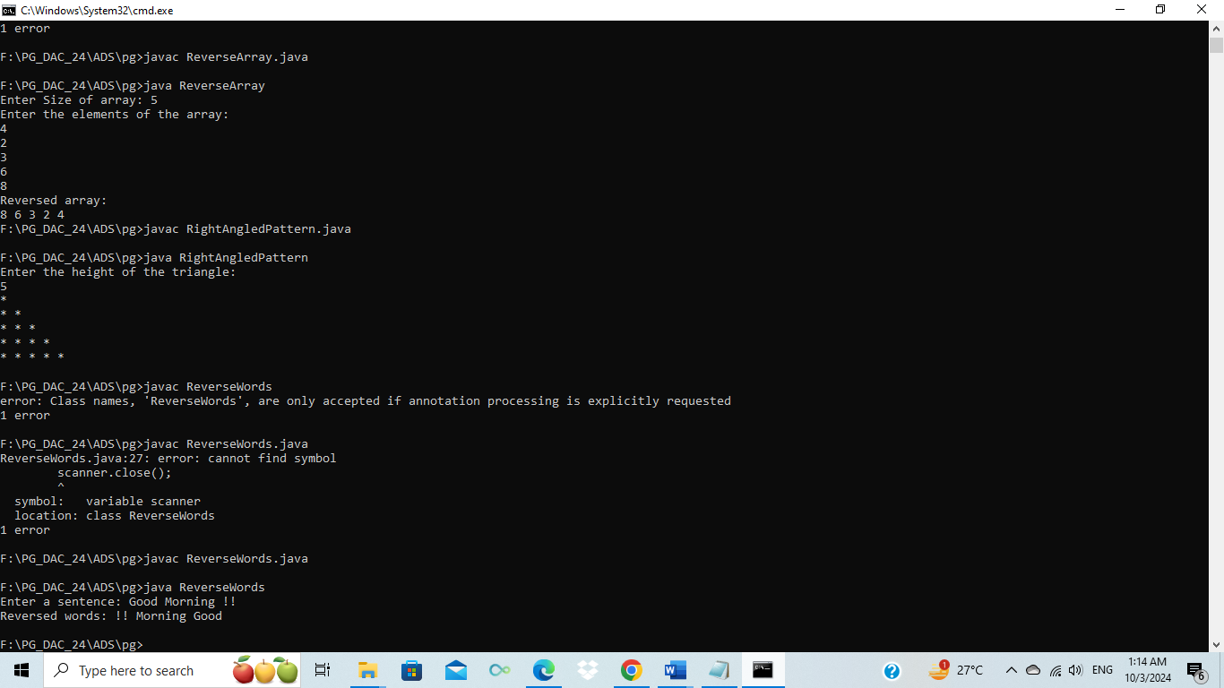

7. Reverse a Number

Problem: Write a Java program to reverse a given number.

import java.util.Scanner;

public class ReverseNumber {

public static void main(String[] args) {

Scanner sc = new Scanner(System.in);

System.out.print("Enter a number: ");

int number = sc.nextInt();

int reversedNumber = 0;

while (number != 0) {

int digit = number % 10;

reversedNumber = reversedNumber * 10 + digit;

number /= 10;

}

System.out.println("Reversed number: " + reversedNumber);

sc.close();

}

}

8. Array Manipulation

Problem: Perform a series of operations to manipulate an array based on range update queries. Each query adds a value to a range of indices.

Test Cases:

Input: n = 5, queries = [[1, 2, 100], [2, 5, 100], [3, 4, 100]]

Output: 200

Input: n = 4, queries = [[1, 3, 50], [2, 4, 70]]

Output: 120

9. String Palindrome

Problem: Write a Java program to check if a given string is a palindrome.

Test Cases:

import java.util.Scanner;

public class PalindromeChecker {

// Function to check if a string is a palindrome

public static boolean isPalindrome(String str) {

int start = 0;

int end = str.length() - 1;

// Compare characters from the start and end

while (start < end) {

// If characters are different, it's not a palindrome

if (str.charAt(start) != str.charAt(end)) {

return false;

}

start++;

end--;

}

// If all characters matched, it's a palindrome

return true;

}

public static void main(String[] args) {

Scanner scanner = new Scanner(System.in);

// Input string

System.out.print("Enter a string: ");

String input = scanner.nextLine();

// Check if the string is a palindrome

if (isPalindrome(input)) {

System.out.println(input + " is a palindrome.");

} else {

System.out.println(input + " is not a palindrome.");

}

scanner.close();

}

}10. Array Left Rotation

Problem: Write a Java program to rotate an array to the left by d positions.

Test Cases:

Input: arr = [1, 2, 3, 4, 5], d = 2

Output: [3, 4, 5, 1, 2]

Input: arr = [10, 20, 30, 40], d = 1

Output: [20, 30, 40, 10]